|  |  |
| --- | --- |
|  | **Narrogin Senior High School**  **2023 – Mathematics Methods Year 11**  Total: 50 marks |

**Calculator Fee /18**

1. [4 marks: 2, 2]

Given that sin 45o = and sin 60o =

|  |  |
| --- | --- |
| a) find *x* if | b) find sin q if |

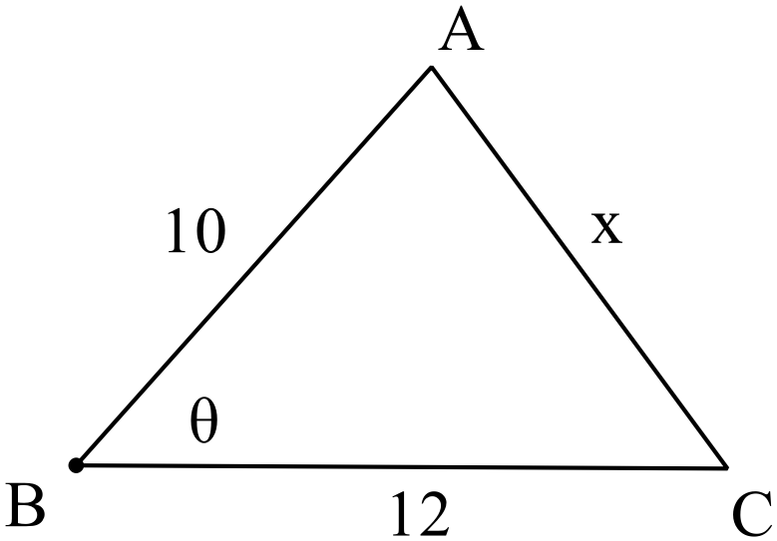

2. [6 marks: 2, 2, 2]

In triangle ABC drawn below, find:

1. the exact value of x if cos q =
2. cos q in exact form if x = 12
3. Find the area of triangle ABC if sin q =

3. [8 marks: 2, 2, 4]

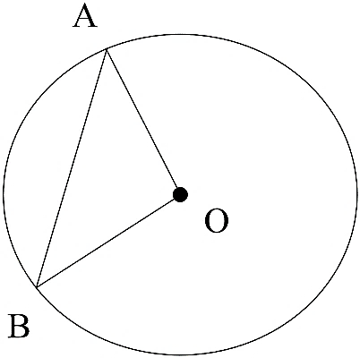 In the circle of radius 6 cm with centre O drawn below, ∠AOB = 30o

1. Find the exact area of triangle AOB.
2. Find the exact area of the minor segment formed by

the chord AB.

1. Find the exact perimeter of the sector OAB.

**Calculator Assumed /32**

4 [9 marks: 3, 3, 3]

(a) Determine the size, to the nearest degree, of the largest angle in a triangle with sides of

lengths 23 cm, 28 cm and 31 cm. (2 d.p.)

(b) Determine the value of *y* in the diagram below. (2 d.p.)

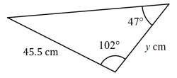

(c) The area of the triangle shown below is 280 cm2. Determine the value of *x*. (2 d.p.)

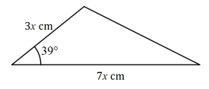

5 [8 marks: 3, 2, 3]

P, Q, R are three spots on a large level farmland. Q is located 1 km from P along bearing 150o. R is located 2 km from Q along bearing 210o.

a) Draw a clearly labelled diagram indicating relative positions of P, Q and R.

State all relevant angles and distances.

b) Find the bearing of P from Q.

c) Find in exact form the distance between P and R.

6. [5 marks]

Consider a rope fixed at B and tightly wrap around a disc A as shown in the diagram below.

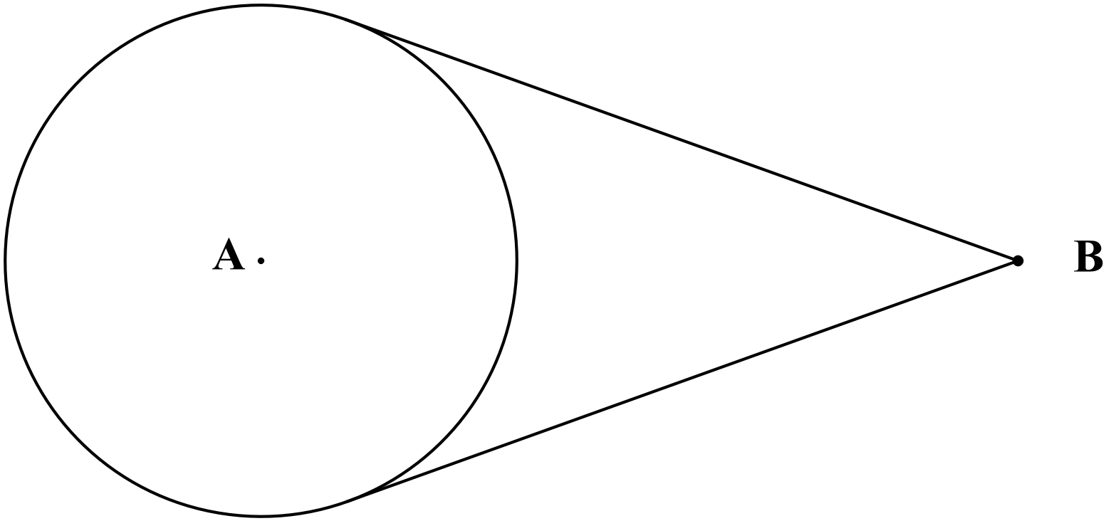

Disc A has a radius of 10cm. If the distance of B from the nearest edge of disc A is twice the radius of disc A, determine the length of the rope. (2 d.p.)

7 [10 marks: 5, 5]

Three circles of radii 5 cm, 3.5 cm and 2 cm are drawn touching each other as shown in the accompanying diagram.

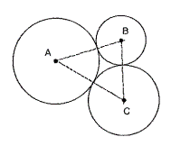a) Find the size of all angles within triangle ABC.

b) Find the area of the region trapped by the three circles. (2 d.p.)